CRASH TEST DUMMIES!!

In this activity you will be using a model car and a plasticine crash test dummy to investigate Newton’s Laws of Motion.

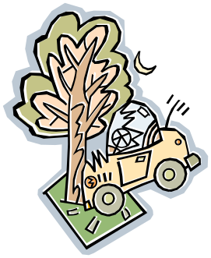
Your group will work together on each of these tasks.

TASK 1: FIRST LAW OF MOTION

“Every object continues in its state of rest or uniform motion
in a straight line unless acted upon by an external force.”

In this activity you will place the dummy on the car, with no restraints, and push the car at a wall with a small force and large force, and then at a ruler that is held rigid and upright with a small force and large force. Then repeat but this time make a seatbelt like restraint for the dummy. Draw a diagram or explain in words what happened to the dummy in each scenario.

Crash Test Dummy | Wall  Small force | Wall  Large force | Ruler  Small force | Ruler  Large Force
No restraint

Seatbelt

Explain in terms of Newton’s First Law what difference the seatbelt made and why?

TASK 2: SECOND LAW OF MOTION

“When an unbalanced force acts on a body that is free to move, it produces acceleration in the direction of that force. The size of the acceleration is directly proportional to the size of the force and inversely proportion to the mass of the body.”

Prove Newton’s Second Law of Motion by designing a quick test using the materials provided. Briefly address each section below. The procedure can be a short paragraph and doesn’t need to be overly detailed.

Materials Used:

Procedure:

Results:

Conclusion:

TASK 3: THIRD LAW OF MOTION

“To every force there is an equal and opposite reaction (force).”

Describe two different pairs of action and reaction forces that were evident from the tasks. Be sure to explain what each force is acting on.

Example 1:

Example 2:

